**NAME : BHAGI RATH MANDA**

**ROLL NO : 89245**

**Assignment – 20 Changing Values through Views.**

1. Which of these views are updateable (will allow DML operations)?

Create view nullcities as

Select snum, sname, city

From salespeople

Where city is null

Or sname between ‘A’ and ‘MZ’ ;

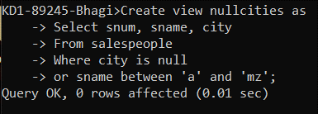

1. Create a view of the Salespeople table called Commissions. This view will include only the snum and comm fields. Through this view, someone could enter or change commissions, but only to values between .10 and .20.

Create view v6 As

Select snum, comm

From salespeople

Where comm > 0.10 and comm < 0.20

With check option;

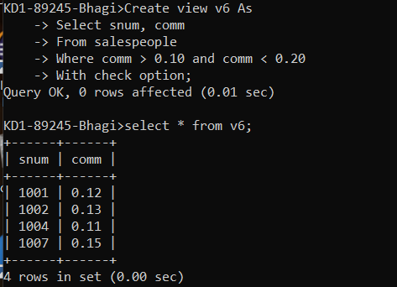

1. Some SQL implementations have a built-in constant representing the current date, sometimes called “CURDATE” or “SYSDATE”. The word SYSDATE can therefore be used in a SQL statement, and be replaced by the current date when the value is accessed by commands such as Select or Insert. We will use a view of the Orders table called Entryorders to insert rows into the Orders table. Create the Orders table, so that SYSDATE is automatically inserted for odate if no value is given. Then create the Entryorders view so that no values can be given.

Create table Orderss(

Onum int primary key,

Cnum int,

Snum int,

Odate datetime default current_timestamp);

